Rescuing the Naamans Among Us
Helping Those Addicted to Pornography
Quotes:
President Monson
My beloved friends, under no circumstances allow yourselves to become trapped in the viewing of pornography, one of the most effective of Satan's enticements. And if you have allowed yourself to become involved in this behavior, cease now.
Seek the help you need to overcome and to change the direction of your life. Take the steps necessary to get back on the strait and narrow, and then stay there.
Elder Russell Nelson:
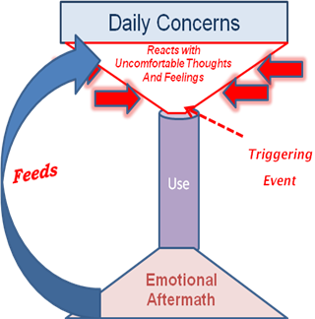
Addiction surrenders later freedom to choose. Through chemical means, one can literally become disconnected from his or her own will
Scripture:
2 Kings 5: Now Naaman, captain of the host of the king of Syria, was a great man with his master, and honourable, because by him the LORD had given deliverance unto Syria: he was also a mighty man in valour, ……but he was a leper.
Key Points:
- Healing from long term exposure to pornography is not simply about exercising will power. It requires following the clear steps laid out in the LDS Addiction Recovery Program manual. True healing comes from completely surrendering to the Lord and His Atonement.
- Addiction to pornography includes addiction to secrecy. Healing requires transparency and disclosure: to a Bishop, a spouse, a counselor or group.
- A wife carries a dual weight of betrayal and blame. She needs to understand that her husband’s addiction is not her fault or responsibility. It has nothing to do with her appearance or amount of marital intimacy. (The spouse’s support group meets Sunday nights at the Carrollton Stake Center at 7:00)
- Those brethren who work closely with their bishop and attend the temple often heal more quickly than those who do not.

