Day 6- Conversion

Reading Assignments:
LDS ARP Manual Steps 11 and 12

Spiritual Principles- Change of Heart
Lets begin the last the last chapter with a question. In the Doctrine and Covenants, the Lord declares: “I the Lord require the hearts of men, and a willing mind.” The question is: what is the heart?
The scriptures are filled with references to “the heart.” There are
- Hard hearts and softened hearts
- Hearts set on wicknedness
- Hearts changed
- Wandering hearts and faithful hearts
- Words that spoke peace “to their hearts.”
So, there are a lot of references to hearts. Is your heart an emotion or feeling? Is it a thought? Is it a combination? And why is it important to know in an addiction class?
The answer to last question is fairly simple. “As a man thinketh in his heart, so is he.” If you are to heal from addiction, what’s in your heart will make a critical difference.
Traditional TFA
Traditionally, it is assumed that our actions are just the last step in a series of internal actions. This process is sometimes shortened to TFA, short for Thoughts, Feelings and then Actions. In other words, we act based on feelings and emotions and those emotions are formed in result to our thoughts and decisions. A good example is as follows:
Let’s say you are sitting in a high office building which overlooks the parking lot where your car is parked. You glance out of the window to see shadowy hooded person slowly approaching your car. He looks around the draws even closer. What does he want? You think. Is he going to try and steal it? As you watch the man reaches out for your door handle. As he does so, what would you feel? Anxiety? Anger? Your emotions build as you watch him reach out and actually opens the car door. Helplessness? What is he doing? You glance around, trying to see how long it would take to get down to the parking lot. Realizing it would take too long, you quickly reach for the phone to call security.
Then, as you watch he reaches into your car, turns off the headllights you’d left on, shuts your door and walks away. Oh! You think, sheepishly, hanging up the phone. You are then flooded with feelings of relief.
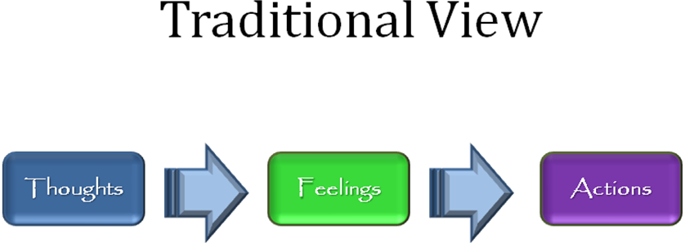
As you watched, your thoughts detected a potential threat to your car. While weighing possible options, your emotions reacted to the thoughts you were having. Eventually, you formulated a plan of action and reached for the phone to carry out your plan to save the car. However, the minute your thoughts changed—Oh, he’s helping me by turning off the headlights so that my battery won’t die!—your emotions immediately changed. Your thoughts provided new information that changed the situation dramatically and your emotions reflected that change.
However, the TFA model only accounts for part of the process. Lets come back to the original question. What is the heart, the Lord speaks so often about? Where is it in the TFA process? Is it Head, (mind, thought, analyzing)? Is it Feeling (Emotion)?
The short answer is that the Heart, the one Heavenly Father looks upon and judges (remember the Ma’at Principle?) is neither head nor heart. It is something completely different.

Addiction Principles- The Morning Devotional

Emotional Principles- Survivorship

